**Deploy webapplication on docker container and intergrate database using docker-compose**

Step 1: configure machine install docker start service , install docker-compose

Step 2: create Dockerfile for tomcat and build image from it

Creating on project.war folder and add Loginwebapp.war and config file of db

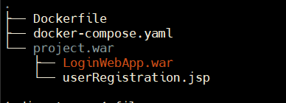

Step 2: create docker-compose.yaml file

Step 3: inside mysql-cont

docker exec -it mysql-db bash

configure database

installing mysql-client

apt update && apt install -y default-mysql-client

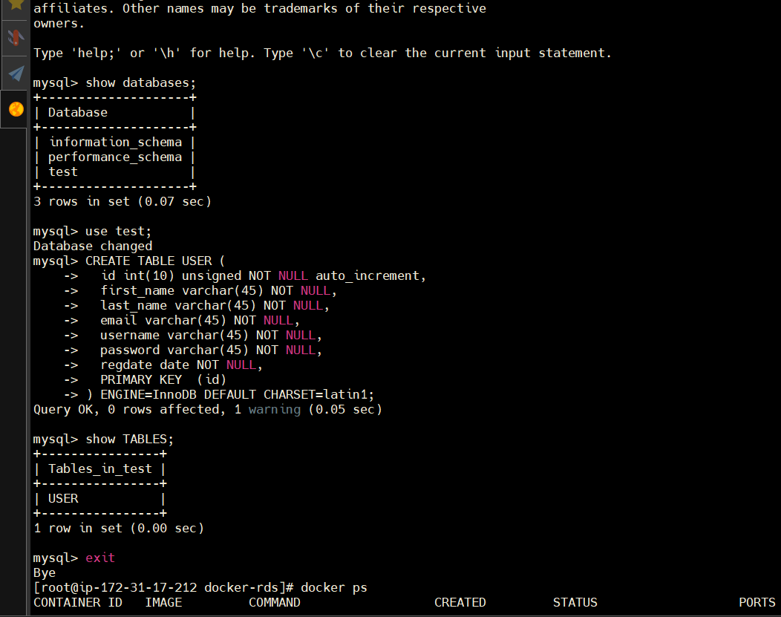

updating db-configuration file

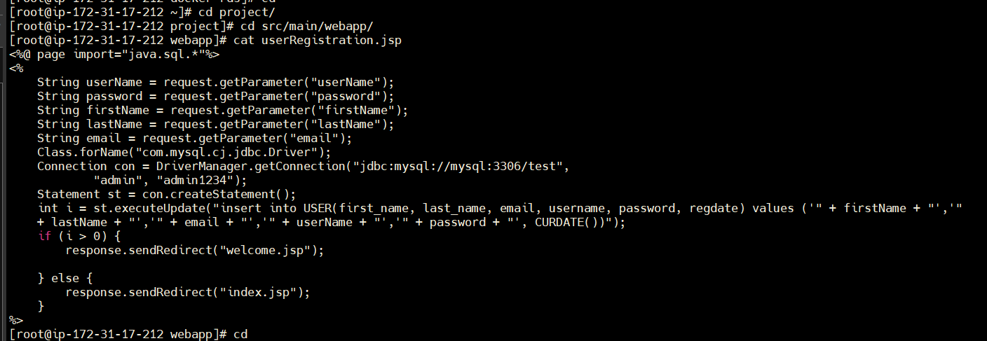

Step : create service using docker-compose

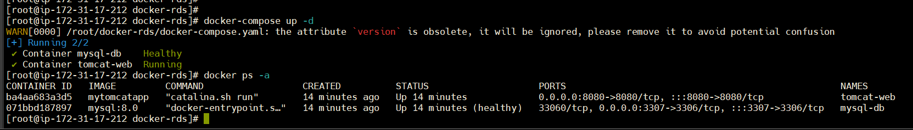

Now try to access and verify

Able to connect



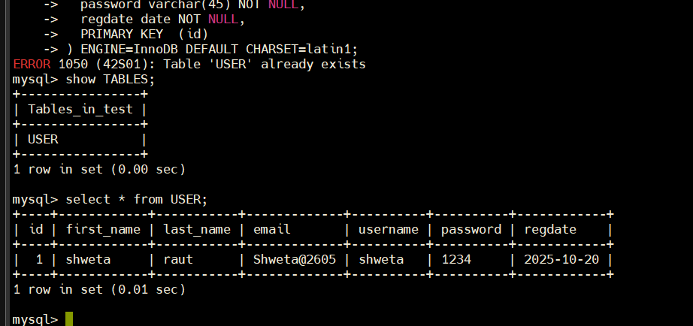

Done!!